The 27th Annual Miracle Ride May 30-31st, 2020
Miracle Ride Support Form
(This form can be downloaded and completed in Microsoft Word)
Yes! I’d like to support the 2020 Miracle Ride benefiting Riley Hospital.

Company/Group Name: Click or tap here to enter text.
Your name: Click or tap here to enter text.
Address: Click or tap here to enter text.
City, State, Zip: Click or tap here to enter text.
Email: Click or tap here to enter text. Bus. Phone: Click or tap here to enter text.
Cell phone: Click or tap here to enter text. Fax: Click or tap here to enter text.
Website: Click or tap here to enter text.

Support Levels Please check all that apply:
☐Title Level Partner $10,000+ ☐Gold Level Support $5,000--9,999
☐ Silver Level Support $1,000--4,999 ☐Poker Run Start Location $3,500
☐ T-shirt sponsor level $300--999 ☐Poker Run Stop Location $1,000
☐Dedicated Group T-Shirt see note below*1 ($2,000) ☐Stage/tent sponsor $100-299
☐ In-kind donations-- Please describe below**
☐Raffle/auction prize donations—Please describe below**

☐I choose to decline the complimentary t-shirts and event passes to save money and give it to the kids.
Authorized Signature: Click or tap here to enter text.
Your P.O. Number: Click or tap here to enter text. total support commitment: $Click or tap here to enter text.
Date: Click or tap to enter a date. **Raffle/auction prize/In-kind item descriptions:Click or tap here to enter text.

Please remit check or money order with this completed form to Miracle Ride Foundation, Inc. 9775 Crosspoint Blvd. Suite 100, Indianapolis, IN 46256, Attn: Gino Johnson. Kindly understand your authorized signature is a binding purchase order commitment upon which the Miracle Ride plans the scope of its events to optimize fund-raising for Riley Hospital. It is payable within 30 days of signed commitment. *¹ Dedicated t-shirt groups/organizations/companies should contact Lori Combs, Registration Manager, to register their riders as a group. Email Lori@miracleride.net or call her 317-370-6694. This assures we get the correct t-shirt quantities and sizes for your group. Details for dedicated t-shirt groups must be completed no later than April 15, 2020. Thank you! Your support is greatly appreciated. Miracle Ride Foundation, Inc. is a 501(c)(3) organization.
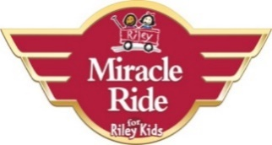
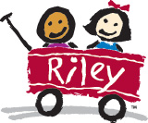

The 27th Annual Miracle Ride is May 30-31st, 2020
Approximately $6.8 million donated to Riley Hospital since 1994.
Hope Happens When We Ride!
Festival License 012371

