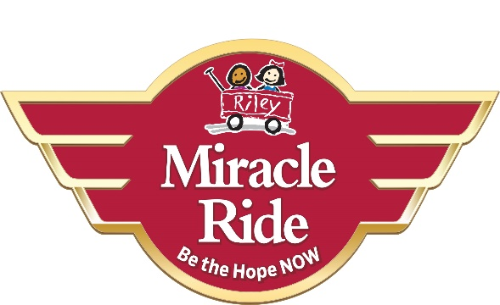
Re: 2022 Miracle Ride Parade Route on Sunday, June 5th from 11:00 a.m. – 12:30 p.m. (approximate times)
Dear Citizens, Churches, and Businesses:
On Sunday, June 5th, the 28th anniversary of the annual motorcycle Miracle Ride for Riley Hospital for Children will conduct a Police Force escorted parade along several streets on the west side of Indianapolis. We are aware of and sensitive to the needs of all residents along the Miracle Ride route. To that end, we want to share information with you about the route, emergency travel, and car routes around the parade.
- In the event of any local emergency along the Miracle Ride route and police, fire or ambulance need to respond, the Miracle Ride participants will stop and yield to all first responders.
- On the opposite page, there are diagrams of the Miracle Ride parade route and alternative car routes around the Miracle Ride parade.
- You can also access the same diagram online at the Miracle Ride website home page at: miracleride.net. Simply click on “Events” and then click on ‘Click here for car routes to avoid the ride.”
- Signs along the Miracle Ride parade route will be placed between May 31st-June 2nd.
We want to thank all of you for the many years of support and encouragement of our cause to help Riley Kids. For example, since 1994, the Miracle Ride has donated more than $6.9 million dollars to Riley Hospital for Children. In fact, The Miracle Ride is the largest community fundraiser for Riley Hospital for Children in the country.
So, when you see us ride past, please be patient and wave at our riders because they donated their hard-earned money to participate. They are riding for all kids by donating money to also help find cures for childhood illnesses. We truly believe that “Hope Happens When We Ride.”
These children will be waving and cheering-on the bikers as we rumble past the hospital. It is truly a life-changing event. This is when we know that these precious children also believe that “Hope Happens When We Ride” too.

